Short term plan

Unit 2 Living things lesson 13 |  | School: №149 ЖОББМ КММ
Date: |  | Teacher name: Егізбек Айкерім
Grade: 5 |  | Number present: | absent:
Lesson title | Reading: Amazing Iron man
Learning objectives | 5.4.1.1 understand the main points in a limited range of short simple texts on general and curricular topics  5.5.3.1 write with support factual descriptions at text level which describe people, places and objects
Learning objectives  (assessment criteria) | Learners will be able to:  - Predict the content of a text  - Read for specific information  - Recall information from a text.
Levels of thinking skills | Knowledge and comprehension

Stages/  Time | Teachers actions | Students actions | Assessment | Resources
Beginning  5 min | Greeting. (Whale class, Individually)  T tells the class to make groups of 2.  Warm up:  Agree/Disagree  Write “I agree” on one side of the board and “I disagree” on the other side. Have everyone stand up and come to the front of the classroom. Say a statement, such as, “Dogs are better than cats.” or “Students shouldn’t bring cellphones to school.” Let students run to “agree” or “disagree” depending on their answer.  Setting the aim of the lesson.   | Learners read the given sentences on the board and guess the topic and share with their ideas.  Remember and recognize the main vocabulary. | Teacher controles the process, gives feedback and asks additional questions if it’s nessasery.  Teacher evaluate pupils with phrases like:  “Good job!  Well done!”  Formative Assessment   | Sheets of peppers  Pictures of to be  https://images.app.goo.gl/KXJWV8NSZEJJc2RS9
Middle  30 min | Task. I (Wh, I) (pair dicsussion)  Ex: 1 P: 22  Direct Ss' attention to the picture and ask if they recognise the man/character, then read the names in the list aloud.  Play the recording. Ss listen and follow the text in their books. Elicit answers to the questions in the rubric then direct Ss to the Word List to look up the meanings of the words in the Check these words box.  Differentiation: define the names and answers to the questions in the rubric from the text. | Learners answer the question.  ANSWERS  The man in the picture is Iron Man/Tony Stark.  Stark Industries is his father's company. Pepper Potts is Tony Stark's secretary. .  Iron Monger is Iron Man's/Tony Stark's enemy | Pair assessment  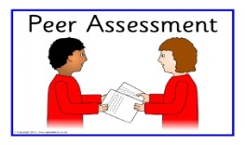  Descriptor:  - read the names  - answer the question.  Total: 2 point | Student’s book
 | Task. II  (Wh, I) (Task for location)  Ex: 2 P: 22  Allow Ss time to read the text again and answer the questions.  Check Ss' answers.  T asks some CCQs:  - Is Tony Stark a worker in his father’s business?  - Can Iron Man fly?  - Can Iron Man protect the world from bad people? | learners read the text again and answer the question  ANSWERS  1 Tony is an engineer.  2 His job is at Stark Industries in the USA.  3 Pepper Potts is Tony's loyal secretary.  4 Tony has got a special metal suit.  5 Iron Man can fly.  6 His enemy is Iron Monger.  Learners answers Yes or No in CCQ ANSWERS  -No  -Yes  - Yes | T’s ffedback  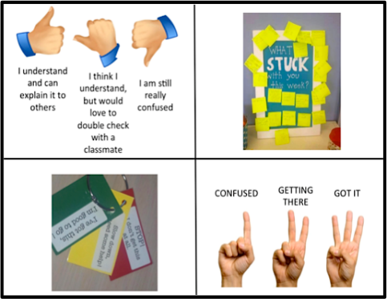  Descriptor:  -read the text  - answer the question  Total: 2 point  Descriptor:  - answers Yes or No | Student’s book
 | Task. III  (Task for understanding)  Ex: 3 P: 22  Allow Ss a minute to read the text, then close their books and try and remember two things from the text.  • Elicit a variety of answers from Ss around the class. | Learners write two things you remember from the text.  ANSWERS  Iron Man can fly.  His enemy is Iron Monger. | Teacher’s comment  Descriptor:  - read the text  - write two things  Total: 2 point
 | Task. IV  Ex: 4 P: 22  Draw Ss' attention to the words and play the recording. Ss listen and repeat chorally or individually.  • Elicit the L1 equivalents from various Ss miming the meaning of each word.  • Refer Ss to the Word List to find the meanings of the adjectives, if necessary. | Learners listen and repeat. What are these words in your language?  ANSWERS  Ss' own answers | Pair assessment  Descriptor:  - listen and repeat  - find the meanings of the adjectives  Total: 2 point
End  5 min | The Ladder method was used as a reflection. T asks Ss to stick their stickers to the Success Ladder.  Green- I understood  Yellow-I have some questions  Red-I need a help.  Ex: P:  Home task | Ss use their stickers to show their knowledge according to the lesson   |  | Poster Success Ladder

